TASK#1:

#include <iostream>
#include "matrix.h"
using namespace std;
{
int a[2][2], b[2][2];
Scalar_Add(a[2][2]);
Scalar _Sub(a[2][2]);
Scalar _Mul(a[2][2]);
Matrix_Add(a[2][2], b[2][2]);
Matrix_Sub(a[2][2], b[2][2]);
Matrix_mul(a[2][2], b[2][2]);
Transpose(a[2][2]);
Determinant(a[2][2]);
Adjoint(a[2][2]);
Inverse(a[2][2]);
Identity(a[2][2]);

return 0;
}

Scalar_Add(a[2][2]);

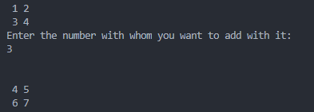
Scalar _Sub(a[2][2]);

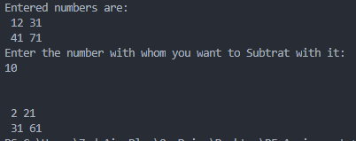
Scalar _Mul(a[2][2]);

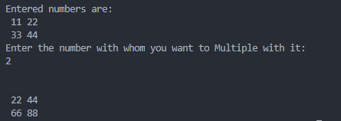
Matrix_Add(a[2][2], b[2][2])

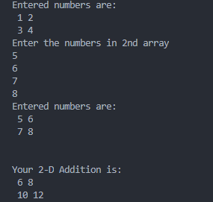
Matrix_mul(a[2][2], b[2][2])

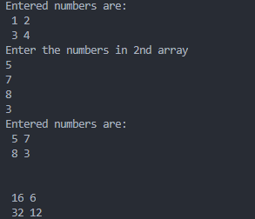
Matrix_Sub(a[2][2], b[2][2])

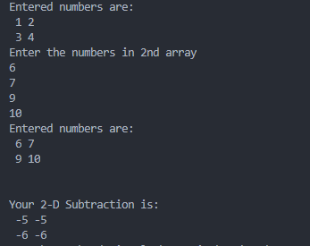
Transpose(a[2][2])

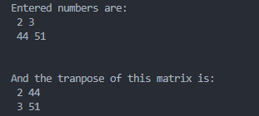
Adjoint(a[2][2])

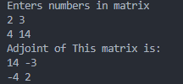
Inverse(a[2][2])

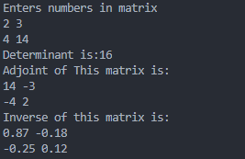
Identity(a[2][2])

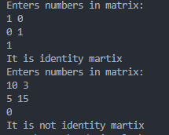

Determinant(a[2][2])

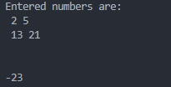

matrix.h:

int Scalar_Add(a[2][2])
{
int b,sum[2][2];
cout<<"Enter the numbers in array"<<endl;
for(int i =0;i<2;i++)
{
for(int j =0;j<2;j++)
{
cin>>a[i][j];
}
}
cout<<"Entered numbers are:"<<endl;
for(int i=0;i<2;i++)
{
for(int j=0;j<2;j++)
{
cout<<""<<a[i][j];
}
cout<<endl;
}
cout<<"Enter the number with whom you want to add with it:"<<endl; //Addition
cin >> b;
for (int i = 0; i < 2; i++)
{

for (int j = 0; j < 2; j++)
{
sum[i][j] = b + a[i][j];
}
cout << endl;
}
for (int i = 0; i < 2; i++)
{

for (int j = 0; j < 2; j++)
{
cout << " " << sum[i][j];
}
cout << endl;
}

return 0;
}

int Scalar _Sub(a[2][2]
{
int b, sub[2][2];
cout << "Enter the numbers in array" << endl;
for (int i = 0; i < 2; i++)
{
for (int j = 0; j < 2; j++)
{
cin >> a[i][j];
}
}
cout << "Entered numbers are:" << endl;
for (int i = 0; i < 2; i++)
{
for (int j = 0; j < 2; j++)
{
cout << " " << a[i][j];
}
cout << endl;
}
cout << "Enter the number with whom you want to add with it:" << endl; //Subtraction
cin >> b;
for (int i = 0; i < 2; i++)
{

for (int j = 0; j < 2; j++)
{
sub[i][j] = b - a[i][j];
}
cout << endl;
}
for (int i = 0; i < 2; i++)
{

for (int j = 0; j < 2; j++)
{
cout << " " << sub[i][j];
}
cout << endl;
}

return 0;
}

int Scalar _Mul(a[2][2])
{
int b, Mul[2][2];
cout << "Enter the numbers in array" << endl;
for (int i = 0; i < 2; i++)
{
for (int j = 0; j < 2; j++)
{
cin >> a[i][j];
}
}
cout << "Entered numbers are:" << endl;
for (int i = 0; i < 2; i++)
{
for (int j = 0; j < 2; j++)
{
cout << " " << a[i][j];
}
cout << endl;
}
cout << "Enter the number with whom you want multiple with it:"<<endl; //Multiplication
cin >> b;
for (int i = 0; i < 2; i++)
{

for (int j = 0; j < 2; j++)
{
Mul[i][j] = b * a[i][j];
}
cout << endl;
}
for (int i = 0; i < 2; i++)
{

for (int j = 0; j < 2; j++)
{
cout <<" "<<Mul[i][j];
}
cout << endl;
}

return 0;
}

int Matrix_Add(int a[2][] , int b[2][])
{
int,sum[2][2];
cout << "Enter the numbers in 1st array" << endl;
for (int i = 0; i < 2; i++)
{
for (int j = 0; j < 2; j++)
{
cin >> a[i][j];
}
}
cout << "Entered numbers are:" << endl;
for (int i = 0; i < 2; i++)
{
for (int j = 0; j < 2; j++)
{
cout << " " << a[i][j];
}
cout << endl;
}
cout << "Enter the numbers in 2nd array" << endl;
for (int i = 0; i < 2; i++)
{
for (int j = 0; j < 2; j++)
{
cin >> b[i][j];
}
}
cout << "Entered numbers are:" << endl; 2D-ADDition
for (int i = 0; i < 2; i++)
{
for (int j = 0; j < 2; j++)
{
cout << " " << b[i][j];
}
cout << endl;
}

for (int i = 0; i < 2; i++)
{
for (int j = 0; j < 2; j++)
{
sum[i][j] = a[i][j] + b[i][j];
}
cout << endl;
}
for (int i = 0; i < 2; i++)
{

for (int j = 0; j < 2; j++)
{
cout << " " << sum[i][j];
}
cout << endl;
}

return 0;
}

int Matrix_Sub(int a[2][] , int b[2][])
{
int sub[2][2];
cout << "Enter the numbers in 1st array" << endl;
for (int i = 0; i < 2; i++)
{
for (int j = 0; j < 2; j++)
{
cin >> a[i][j];
}
}
cout << "Entered numbers are:" << endl;
for (int i = 0; i < 2; i++)
{
for (int j = 0; j < 2; j++)
{
cout << " " << a[i][j];
}
cout << endl;
}
cout << "Enter the numbers in 2nd array" << endl;
for (int i = 0; i < 2; i++)
{
for (int j = 0; j < 2; j++)
{
cin >> b[i][j];
}
}
cout << "Entered numbers are:" << endl;
for (int i = 0; i < 2; i++)
{
for (int j = 0; j < 2; j++)
{
cout << " " << b[i][j];
}
cout << endl;
}

for (int i = 0; i < 2; i++)
{
for (int j = 0; j < 2; j++) //2D-Subtraction
{
sub[i][j] = a[i][j] - b[i][j];
}
cout << endl;
}
for (int i = 0; i < 2; i++)
{

for (int j = 0; j < 2; j++)
{
cout << " " << sub[i][j];
}
cout << endl;
}

return 0;
}

int Matrix_mul(int a[2][2] , int b[2][2])
{
int sum[2][2];
cout << "Enter the numbers in array" << endl;
for (int i = 0; i < 2; i++)
{
for(intj=0;j<2;j++)
{
cin>>a[i][j];
}
}
cout<<"Entered numbers are:"<<endl;
for(int i=0;i<2;i++)
{
for(int j=0;j<2;j++)
{
cout<<""<<a[i][j];
}
cout<<endl;
}
cout<<"Enter the numbers in 2nd array"<<endl;
for(int i=0;i<2;i++)
{
for(int j=0;j<2;j++)
{
cin>>b[i][j];
}
}
cout<<"Entered numbers are:"<<endl;
for(int i=0;i<2;i++)
{
for(int j=0;j<2;j++)
{
cout<<""<<b[i][j];
}
cout<<endl;
} //2-D Multiplication
for(int i=0;i<2;i++)
{

for(int j=0;j<2;j++)
{

for(int k=0;k<2;k++)
{
sum[i][j]=a[i][k]*b[k][j];
}
}
cout<<endl;
}
for(int i=0;i<2;i++)
{

for(int j=0;j<2;j++)
{
{
cout<<" "<<sum[i][j];
}
}
cout<<endl;
}

return0;
}

int Transpose(int a[2][2])
{
int detr;
cout<<"Enter the numbers in array"<<endl;
for(int i=0;i<2;i++)
{
for(int j=0;j<j;j++)
{
cin>>a[i][j];
}
}
cout<<"Entered numbers are:"<<endl;
for(int i=0;i<2;i++)
{
for(int j=0;j<2;j++)
{
cout<<" "<<a[i][j];
}
cout<<endl;
}
for(int i=0;i<2;i++)
{Determint

for(int j=0;j<2;j++)
{
detr=a[0][0]*a[1][1]-a[0][1]*a[1][0];
}
cout<<endl;
}
cout<<detr;

return 0;
}

int main()
{
inta[2][2],transpose[2][2];
cout<<"Enter the numbers in array"<<endl;
for(int i=0;i<2;i++)
{
for(int j=0;j<2;j++)
{
cin>>a[i][j];
}
}
cout<<"Entered numbers are:"<<endl; //Transpose
for(int i=0;i<2;i++)
{
for(int j=0;j<2;j++)
{
cout<<""<<a[i][j];
}
cout<<endl;
}
for(int i=0;i<2;i++)
{

for(int j=0;j<2;j++)
{
transpose[j][i]=a[i][j];
}
cout<<endl;
}
cout<<"And the tranpose of this matrix is:"<<endl;
for(int i=0;i<2;i++)
{

for(intj=0;j<2;j++)
{
cout<<""<<transpose[i][j];
}
cout<<endl;
}

return 0;
}

